Lab 8 : In-class exercises
Trần Quốc Nam- ITITIU21250
- Project setup and Entity
- DTO layer
- Repository and Service layer
- REST controller
- Result

- Project setup and Entity
  - Project setup
Initialize project with Spring boot version 3.5.8 , Java 21, and dependencies
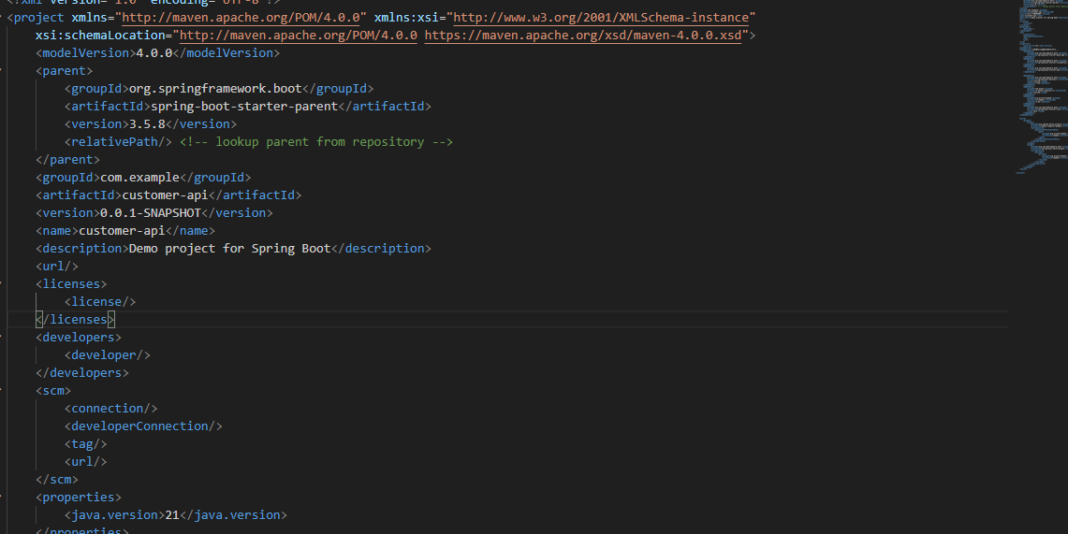
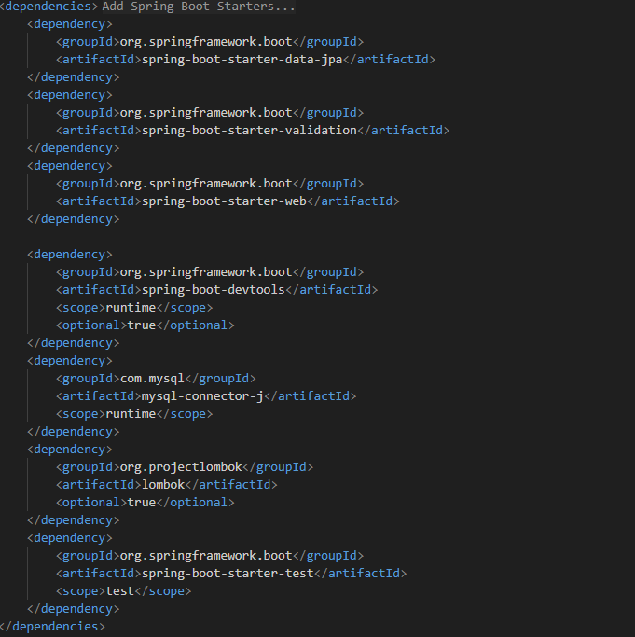

Project structure
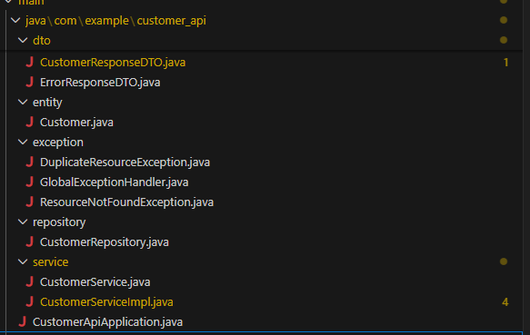
  - Entity
Create user table with sample data
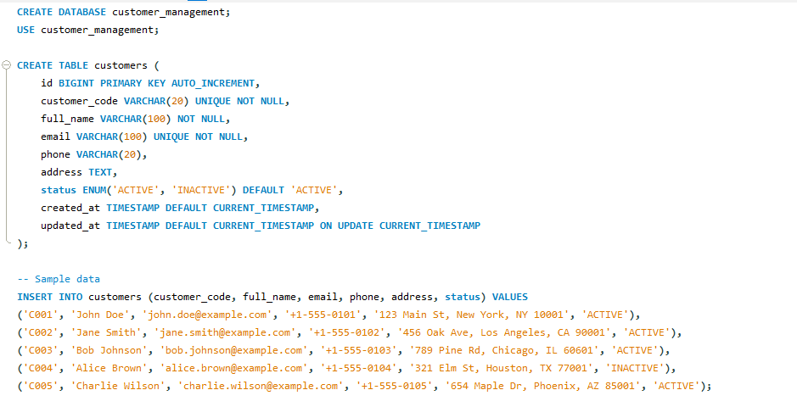

- DTO layer
Data Transfer Objects - An object that carries data between processes.
Purpose of this layer:
- Serves as simple data container that carry only necessary information without business logic
- Simplified communication: provide a clear and structured way to define the contract for data exchange, making it easier for different parts of a system or different application to communicate and understand the expected data formats
- Data control and security: by defining specific DTOs, developers can control which data fields are exposed to different layer or clients
- Optimized data transfer: allow for the selection and packaging of only relevant data needed for specific operation or client.
  - Request DTO
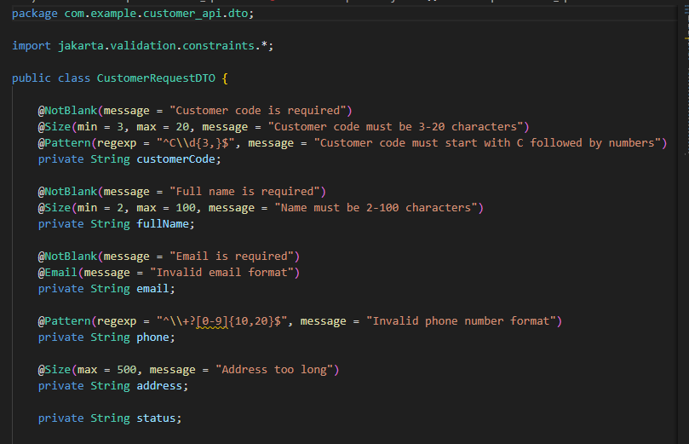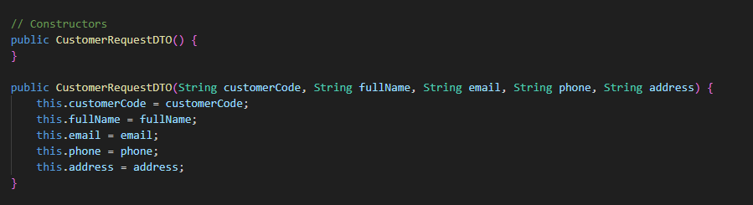
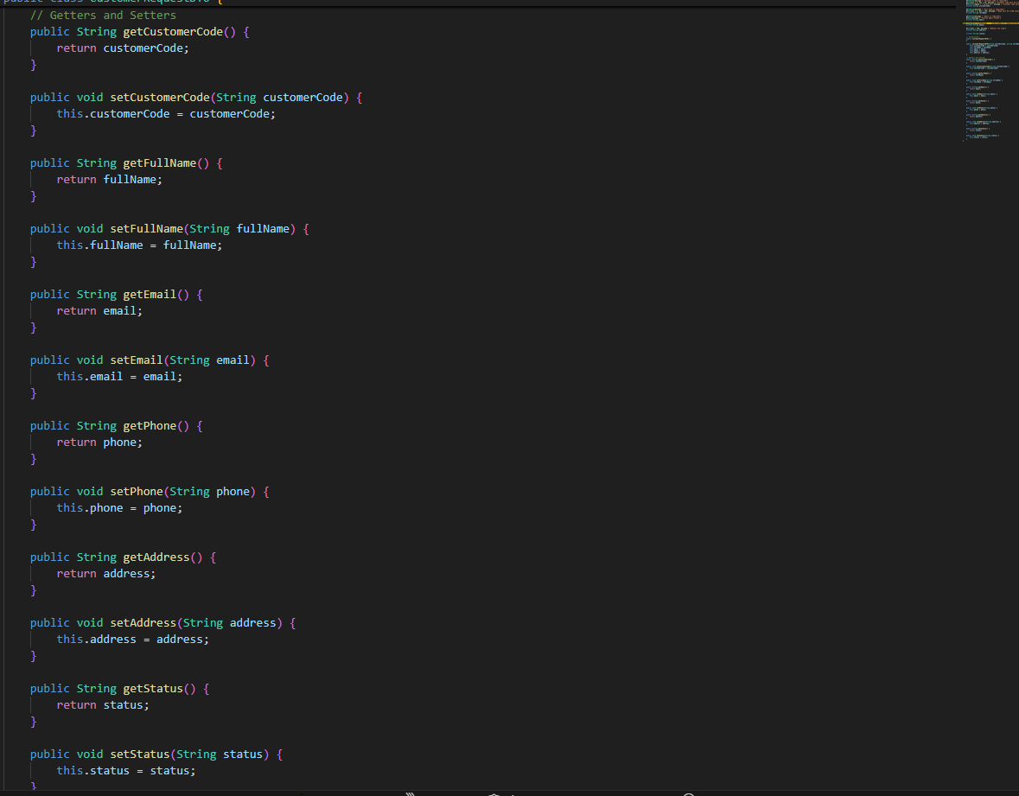
  - Response DTO
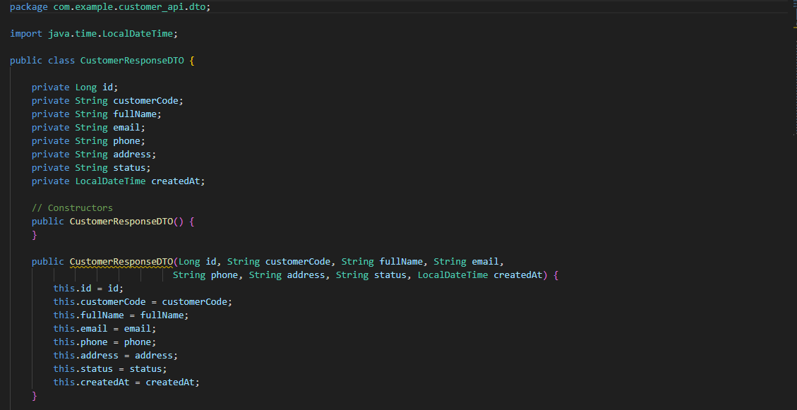
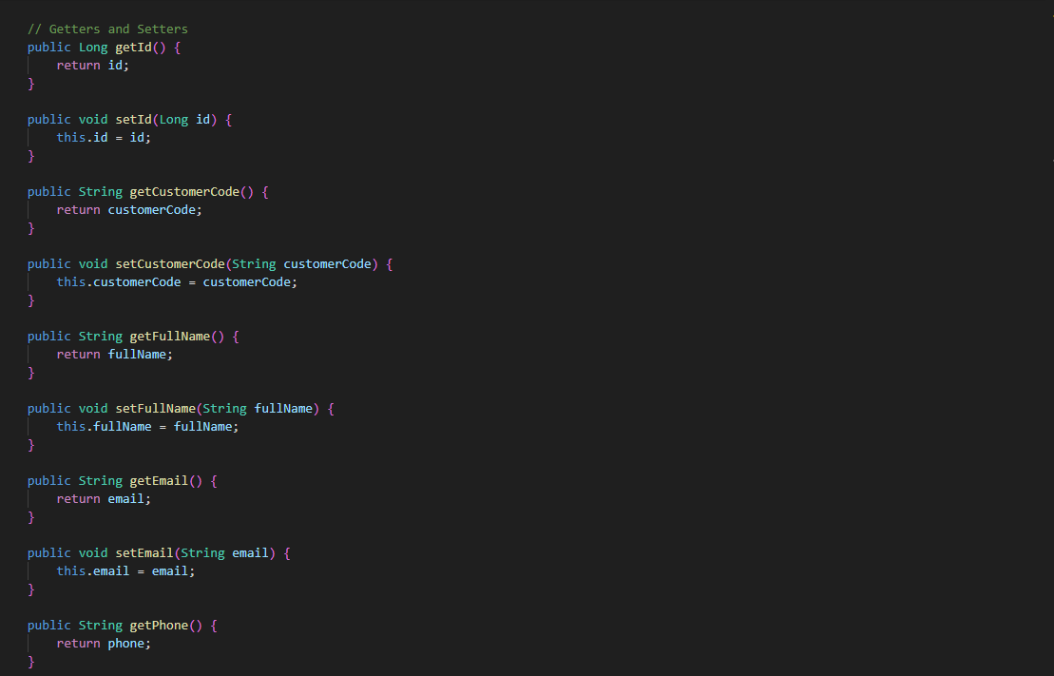
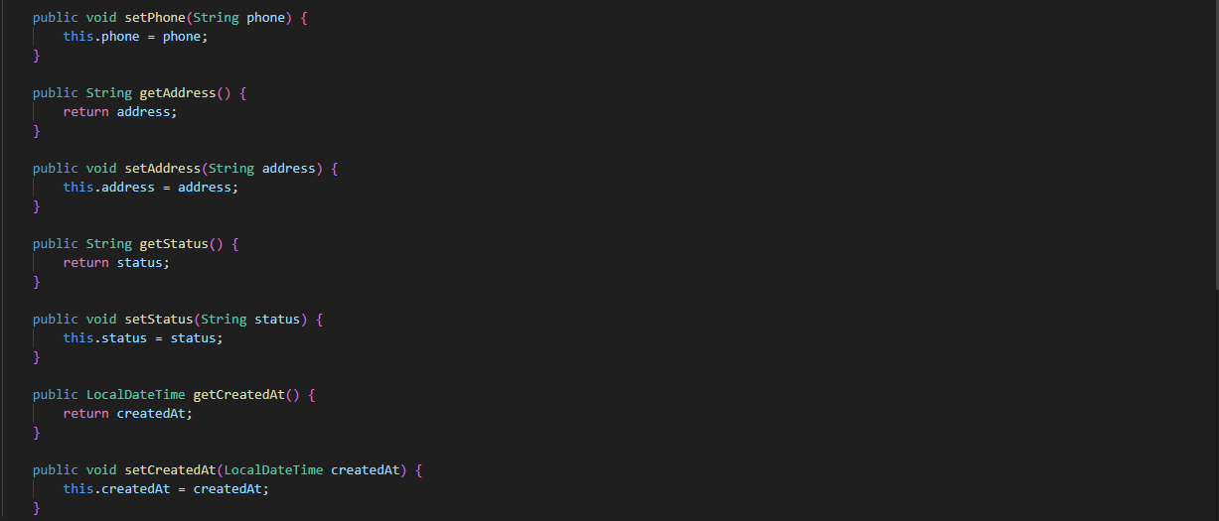
  - Error response DTO
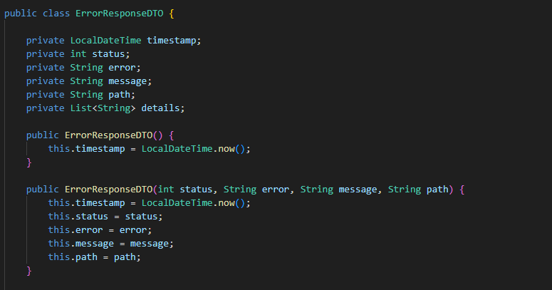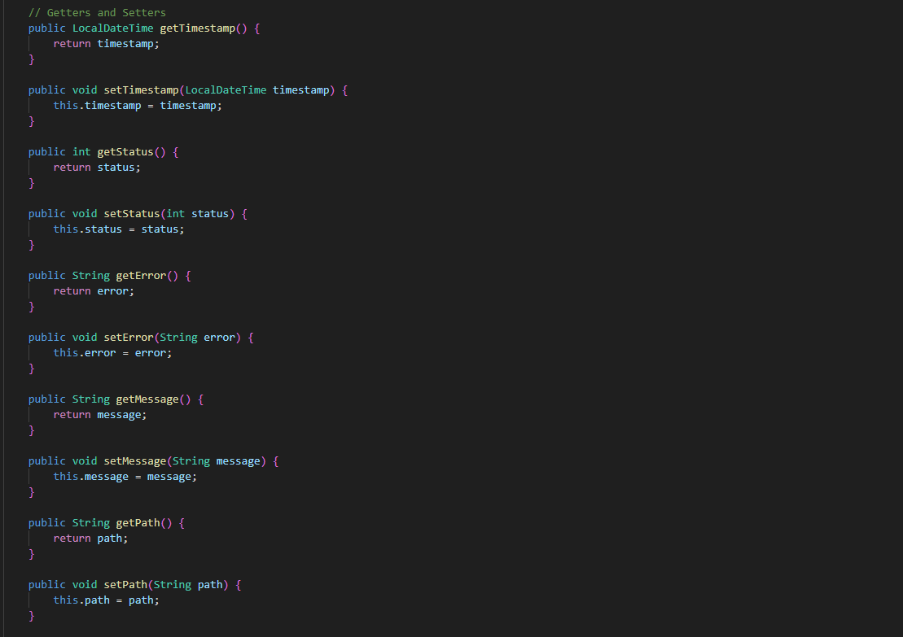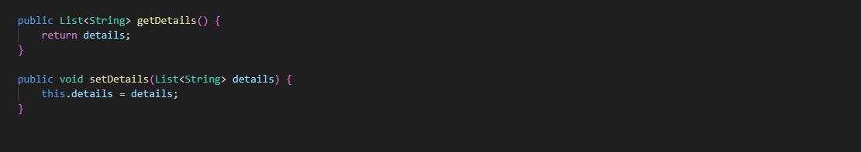

- Repository and Service layer
  - Repository layer
Layer that handles database query, called by service layer
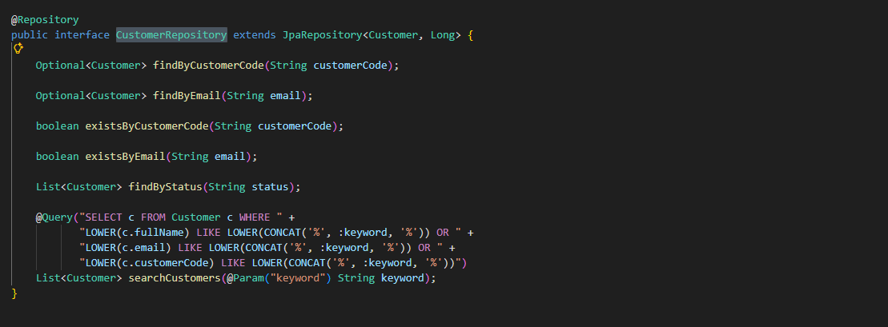
  - Service layer
Layer that handles business logic, called by controller layer
Basic flow of service layer:
Service layer will receive request from controller layer -> execute business logic -> calls repository layer to executes query in database -> database response -> service calls to DTO layer to format response -> return response formatted data object to controller layer

Service interface:
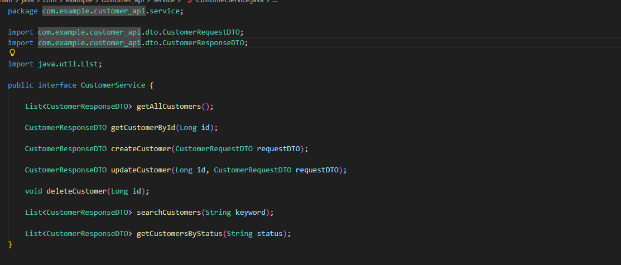

Service implement:
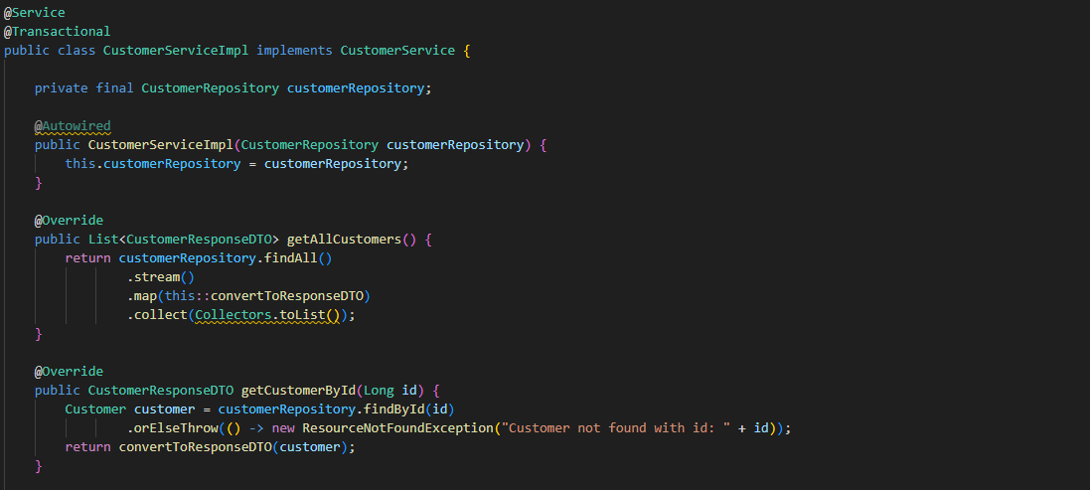
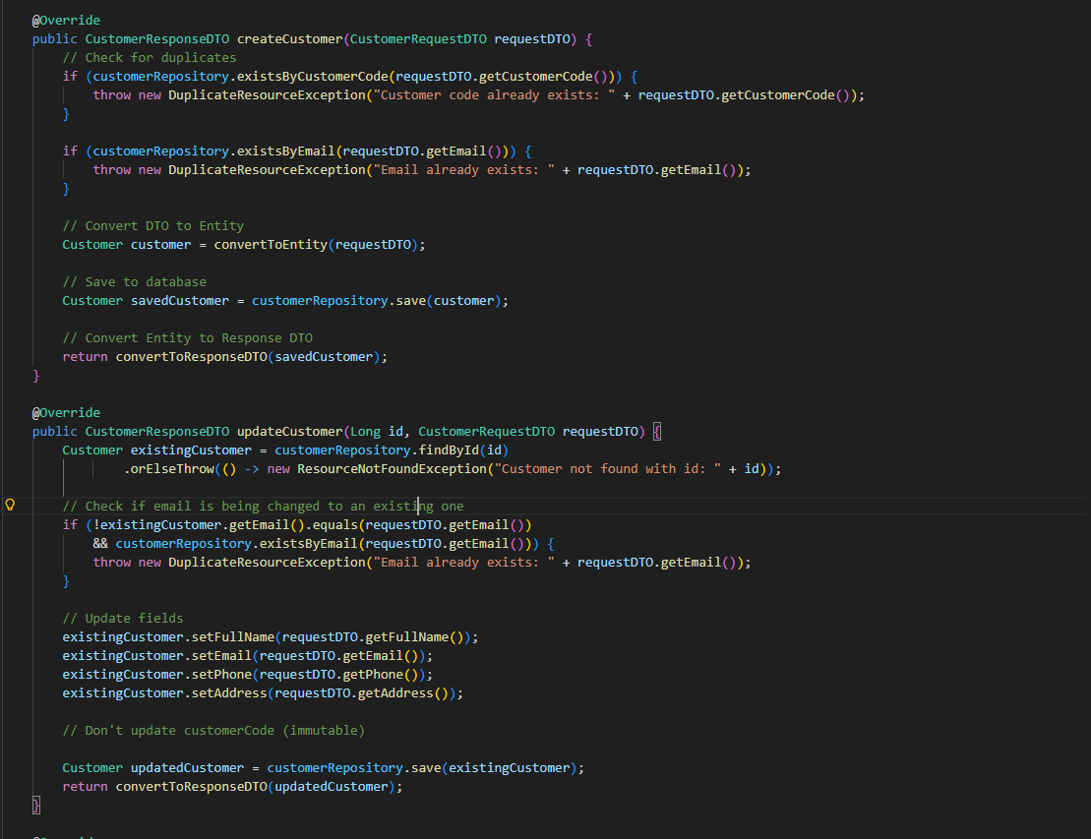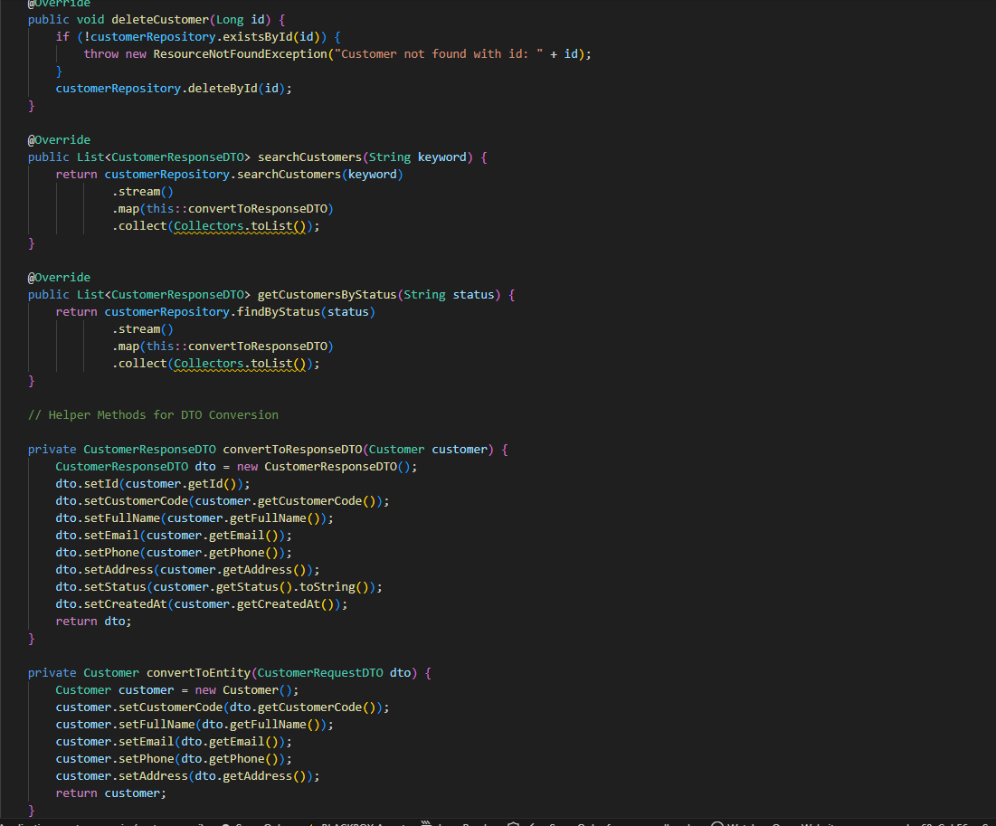
- REST controller
This layer will in charge of managing communication between server side and client side ( taking request and send response )

  - Create basic REST controller
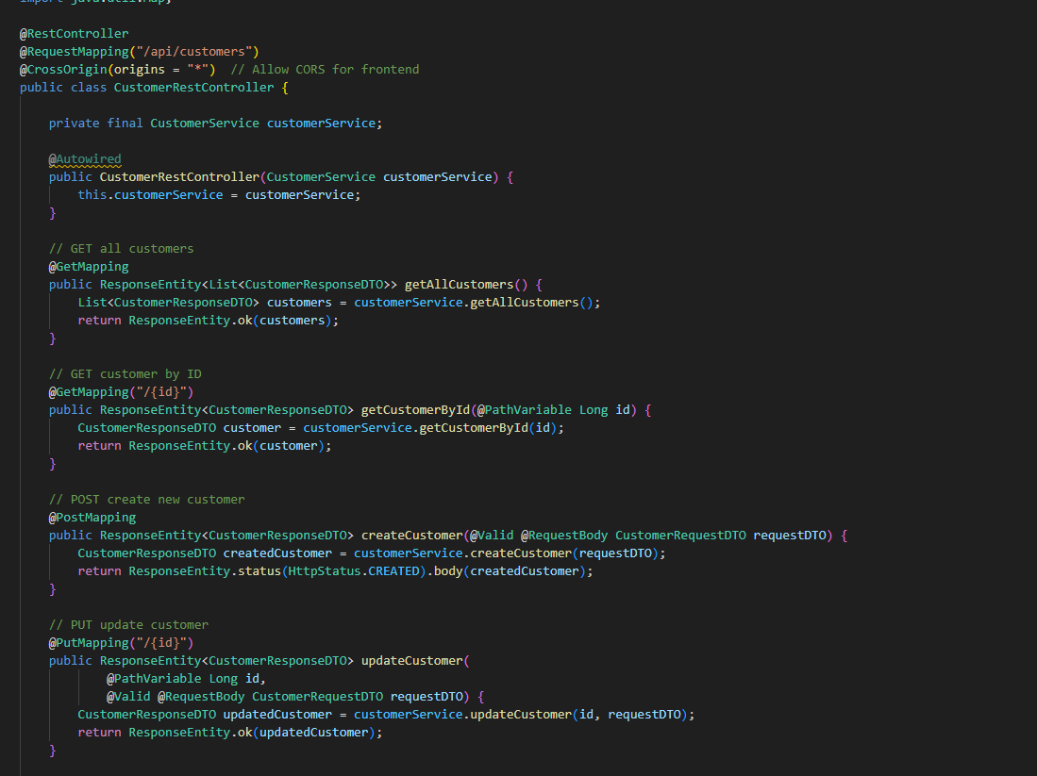
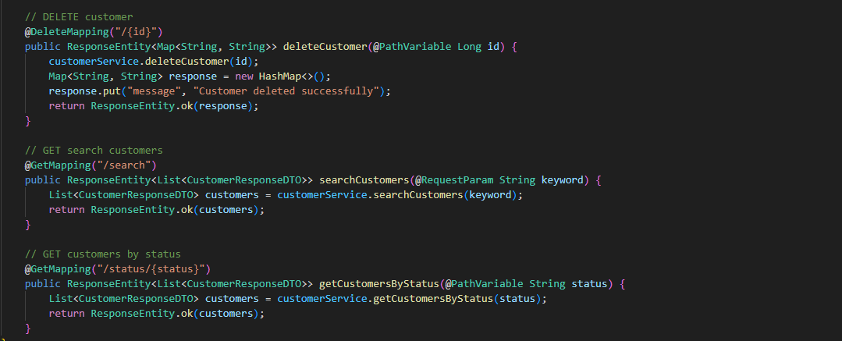
  - Add exception handling
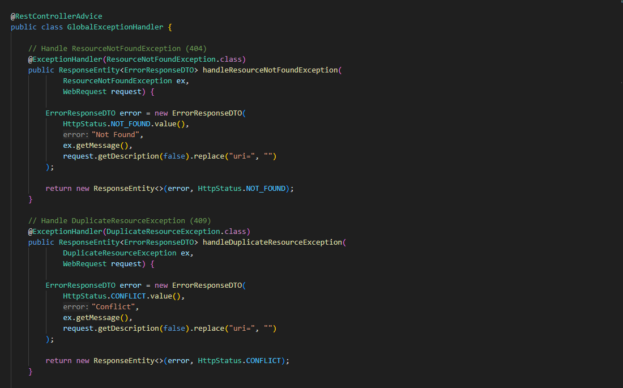
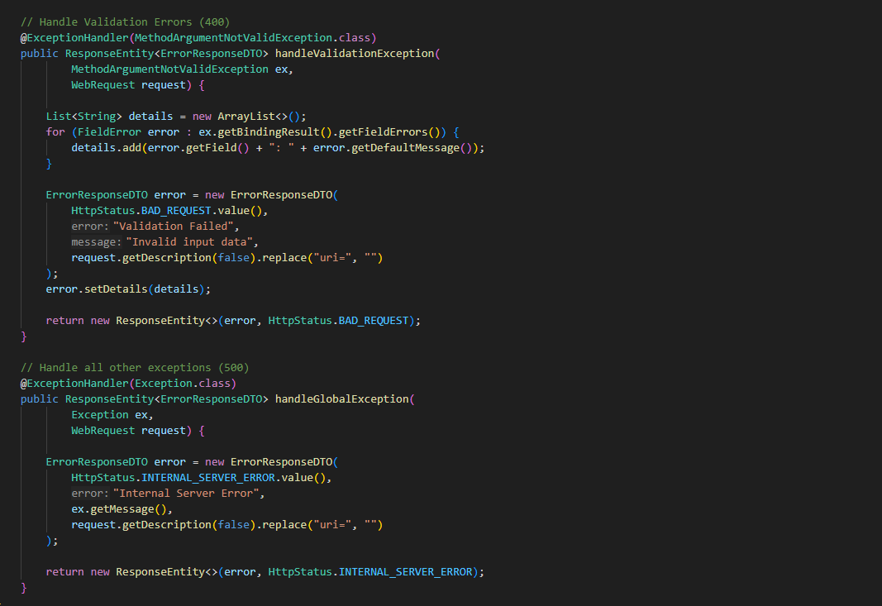

- Work flow and result:
Request and response in RESTful API mostly represented as data object ( usually json file )
In RESTful API method, actions ( GET / PUT / DELETE / POST) will be defined in header
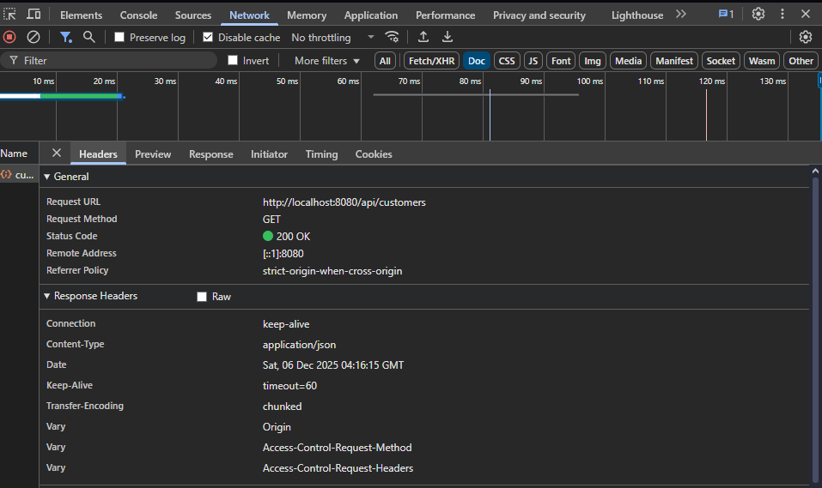
Body will determine the content of the actions
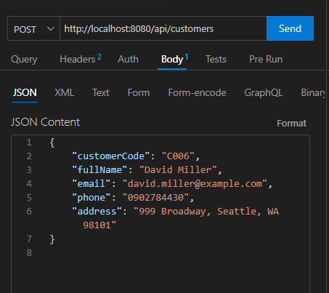
  - Get all customer
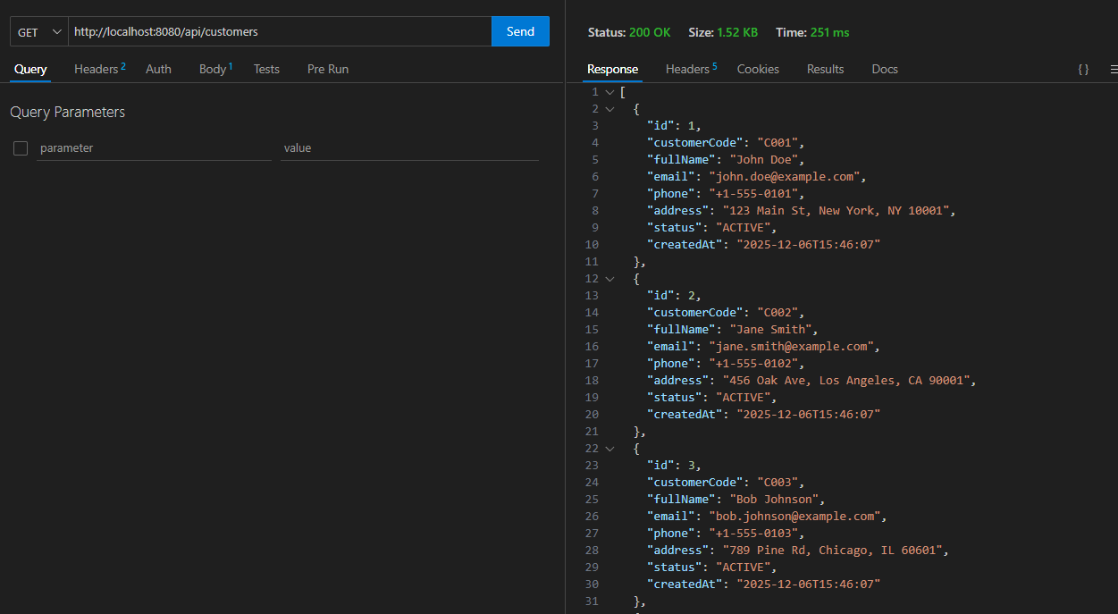
Work flow :
->Browser send url request with method GET in header ( no content in body request )
-> controller takes request
-> maps the url with suitable action
-> calls to service layer
-> service layer performs business logic
-> service layer calls Repository layer
-> Repository execute query and return data table to service layer
-> Service layer call to DTO to format the response
-> return the formatted response to controller
-> controller response data as object file ( json file ) with mapped attributes

5.2 Get user by id
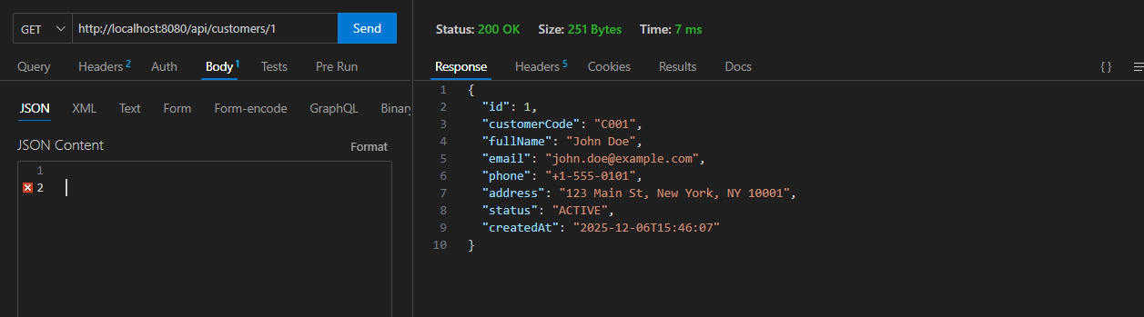
Work flow
→ Browser sends URL request with method GET in header (no content in body request)
→ Controller receives the request
→ Controller maps the URL to the suitable action based on @GetMapping("/{id}")
→ Controller calls the Service layer
→ Service layer performs business logic (validation, processing, etc.)
→ Service layer calls the Repository layer
→ Repository executes the query and returns the data (Entity) to the Service layer
→ Service layer converts the Entity to a DTO to format the response
→ Service layer returns the formatted DTO back to the Controller
→ Controller responds the data as a JSON object with mapped attributes

5.3 Create user
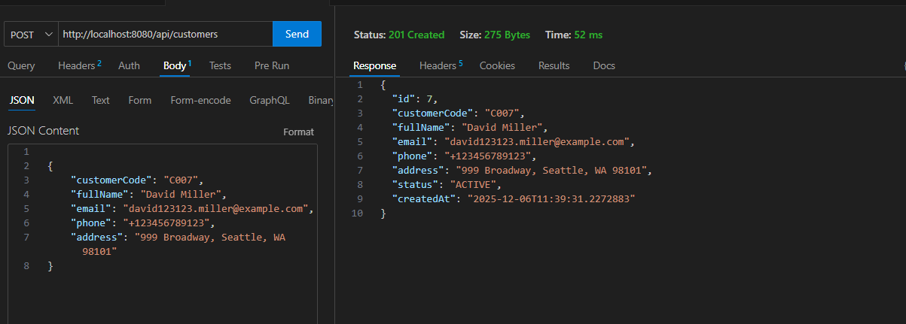
Work flow:
->Browser/Postman sends URL request with method POST and includes JSON body in the request
→ Controller receives the request
→ Controller maps the URL to the suitable action based on @PostMapping
→ Controller reads the JSON body and maps it into the Request DTO (@RequestBody CustomerRequestDTO)
→ Controller calls the Service layer
→ Service layer performs business logic (validation, processing, default values, status, timestamps, etc.)
→ Service layer calls the Repository layer
→ Repository executes INSERT query and saves the new customer into the database
→ Repository returns the saved Entity (with generated ID, timestamps, etc.) back to the Service layer
→ Service layer converts the Entity to a Response DTO (CustomerResponseDTO)
→ Service layer returns the formatted DTO to the Controller
→ Controller responds with a JSON object and sets HTTP status 201 CREATED

